**STUDENT BUSINESS PLAN PROJECT TEMPLATE**

**Executive Summary**

YourShoes is a manufacturer and retail company that bring shoes design and quality to a new level. Our business worth a millions in dollar and consist of 35 members distributed in different departments. Our main office is located in Toronto and our production site will be located in either Scarborough or Mississauga. Our biggest mission is to bring customers a new experience in shoes design selection with affordable price and ease of choosing. We also produce to customers high quality shoes, with the most comfortable level and experience level. We connect customer with one of a professional design where they can request a design and custom their shoes. For every produced shoes, we give 5% the price to the accord designed artist, no matter retail or wholesale. After customer selected their design, YourShoes will handle and responsible for shoes making and send them out to customer. This way, customer can make a no-stop shop for shoes when they visit YourShoes, where they can choose their best design and get every handle all at once. YourShoes fits with all customers: Gender, Ethnic, Age, Demographic, or Occupation, we all wear shoes, it just different in the way how it looks to fit the

culture, in which, YourShoes can also do it. We believe this entrepreneur has potential, as it enhanced the way customer shop, especially their shoes. All the time, customers have to go at least 3 different stores to choose what they are looking for, as either one store doesn't have the exact one but come with a reasonable price or one store offer a really nice looking design but overpriced. YourShoes allows customer to select their own/favourite design and get it done with the same quality they can get from the shoes in those store. Pricing is a bit above the average but it always worth to get what your like. The owner of this business must be able to foreseen the changes in the future as many competitors will likely to jump in for a piece of the cake and he/she needs to make the business stand out from the rest of the competitor, as always in every business. As we are the leader in this business model, we must take this opportunity and make changes to the product or method when applicable so that every other competitors must follow us but they can't never beat us, or at least make it better than us. This implementation required lots of resources from the beginning to gain the market and shape this product market, therefore, we are looking forward to becoming one of the strongest entrepreneur in this market.

**Business Name**

* YourShoes

**Description of Business**

* My business is a freelance area for designers to design their favorites shoes and get their designs sells online. Customers can choose their favorite design or ask for their own custom design. The part about making shoes will be handled by us.
* Customers have 2 options: vote for styles they want the most which the result will release each month and get the shoes to produce at high quantity for good price or get their own custom shoes (high price)

**Form of Business Ownership**

* In the beginning, we surely want to do corporation as we are looking for investors as well as people who well understand in this field to help us. In specifically, I will hold at least 51% to keep my ownership of the company, the rest can be shared amongst the investors for each round call.

**Ideal Customer**

* This could be any kind of customer because who doesn't wear shoes.

**Our Advantages**

* Our company is unique from others is because we allow customers to choose or customize their favorite one. You don't want to go from store to store just to find shoes that match you. We can do it for you even you are at home

**Ethical Issues**

* Privacy is the number one concern for everybody, therefore securing our customer's database at top priority. We will not sell our customer’s database at all cost. Responsibility will be taken from us if any of your personal data is leaked that happened to be in our side.
* Any act of Steal or Fraud (swap products) is considered illegal and must not exist in our working environment. We will take serious involvement if discovered anybody in the team commit it.
* Our products are premium and make from high-quality materials, therefore if customers found out the product was made with low-quality materials, we will take the product back (shipping included from us) and make a compensation up to twice value of the products.

**Social Responsibility**

* We will try to participate in local events such as running, sports events (by sponsoring the event shoes we made), from that, we can also advertise our products and services at the event to engage more people coming to our services.
* On the other hand, if you have leftover shoes that are out of style or customers no longer want it, instead of giving a discount, we can use it to donate to the orphanage. This way, we can help the local orphanage and also clear our inventory.

**Global Issues**

Do you think that you’ll sell your product in another country? If so, what countries would you choose, and why? What challenges will you face?

* We are confident that our idea can go anywhere in the world, because, everyone wears shoes. But first, we would like to build our reputation as well as strength in Canada and the United States before we can move to another country. Once everything is set up, it is easier to set up in a new country. The challenge we might face is shipping cost and currency exchange. My first target to expand in Europe because their currency is higher than us, easier for us to sell the product and Europe is not far away from North America so the shipping could be lower

**Mission Statement**

Provide a brief mission statement for your business

* Our mission statement is to provide customers with the best feeling always feel proud about themselves in wherever they go. We all walking a lot in the day, people sometimes look at your shoes and judge who you are, so why not let us make you feel proud and happy with everyone? What we different from them is, we let you to choose what you want

**Business Goals**

Consider the goals of your business. What are three of your business goals for the first year? What are two intermediate to long-term goals?

**Short-Term Goals**

* The first goal is to get customers to know about the product and service. This is a challenging one because your business success or failure is all in this first stage. If they enjoy your product, they might tell their friend about it, if not they surely tell their friend not to use the service no matter if your service will perfectly match to that future customer.
* In the meantime, we are hoping to reach 12000 customers by the end of the first year, that’s 1000 a month or 3 every day. We are very looking forward as this kind of business is still very new in the market and I am hoping to attract people who are interested in it
* Available to accommodate customers outside of North America when they order our product (shipping, import taxes, etc.,)

**Long-Term Goals**

* Expand our service more in North America to attract more customers and also build our reputation for worldwide service.
* Build a strong customer service team to address all the problem. As we are expanding, more problem and issue will appear and we don’t want to left it to unsolved.

**SWOT Analysis**

Perform a basic SWOT analysis for your business, listing its main strengths, weaknesses, opportunities, and threats.

* **Strengths:** Our concept is new in the market so we can consider as the leader, that leave us **s**tands out from our competitor.
* **Weaknesses:** We understand that shoes make with custom design/image will sometimes look different in reality and we are trying to make it as much similar as possible. Because of that, sometimes our product will not satisfy our customers.
* **Opportunities:** Because this is a new market, as it involves not just customers but also designers so this is like an open field or market. All customers who interest in this can only join us as we are the only one at the moment.
* **Threats:** Definitely new competitor. Once we begin our idea, new competitors will join the market as I can see the potential future. We never know what they will do once they join our market so we always have to work more than what we planned and come up with some unique style so that no competitor can follow or take advantage

**Management**

* There will be 3 levels of management. The first level is to manage all the employees, address some complex issues and solve problems without the help of the upper level. The next level is Short-Term management. This Management level basically manages all the manager in level 1 to make sure that they are still on track and not doing anything wrong. To achieve the bigger thing, we have to collect all the small part so I think this level is the most important one. The highest level is the manager of the Long-Term process as they keep track of all the process the company required to achieve a bigger step. If there is a delay, the level of management which caused the delay will have to take responsibility

**Organization Chart**

Show how the “team” fits together by creating a simple organizational chart for your business. Make sure that you organizational chart indicates who will work for each manager as well as each person’s job title.

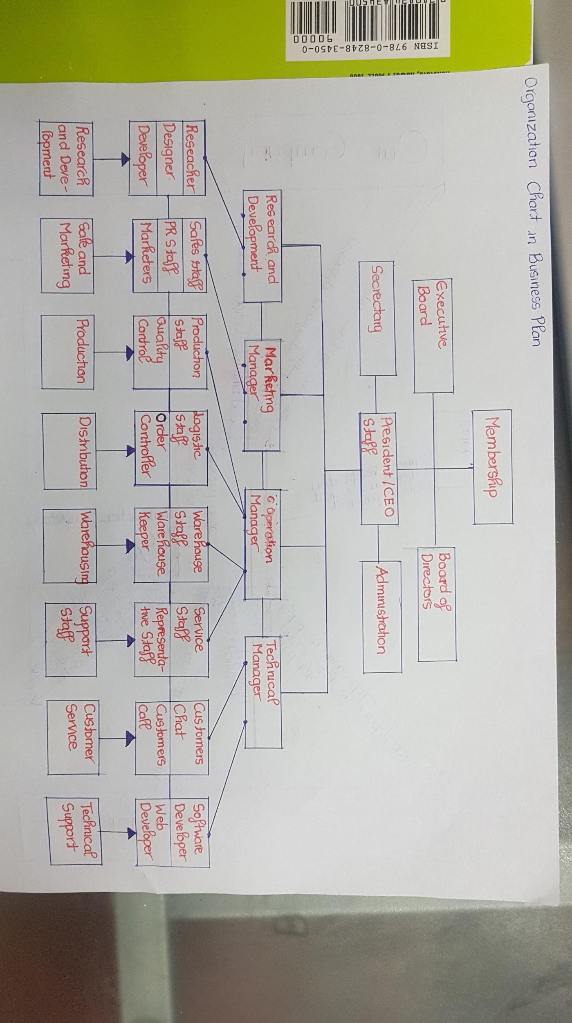

**Corporate Culture**

What do you see as the “corporate culture” of your business? What types of employee behaviors, such as organizational citizenship, will you expect?

* This business will more likely to be in casual environment, however, some option required professional environment.
* **Vision**: Our company is one of the most potential business in the same market, but we have to carefully calculate our way as competitors can jump in at anytime. We must develop some unique features that will keep us stay as the leader in the market.
* **Values**: We consist in a strong team from Junior Designer to Director of Business Marketing with full experience of Customer Service. They all trained at the same level of professionalism to meet customer's expectation.
* **People**: We might not have the best people in the market but we care about team chemistry more than anything else because we believe if a team can work together, every problem can be solved. Our company consists of people who fits the team most.
* **Place**: Professionalism appear differently in business environment. Some required serious act such as airport business, different from art business environment where people can freely do what they want. Since our company is more about designing, we would give our business a freely environment so they can go beyond what they can

**Leadership Philosophy**

What is your philosophy on leadership? How will you manage your employees day-to-day?

* Managing employees day-to-day isn't really the style. Since we have determined our business in casual environment, therefore we would not control our employee on how they do, but keeping target on track is still strictly required every month just so that our company in general and our employee in specifically are on the right track. I sound like this is a free environment but I believe following employees daily/weekly on how they do isn't going to bring more benefits to both sides

**Job Descriptions**

Looking back at your organizational chart in Part 2(a), briefly create a job description for each team member.

* **Director of Business Marketing**
  + As a Director of Business Marketing, your job is to ensure the product can reach the maximum amount of customers. You must be proactive to develop, planning and executing different ways of marketing such as promotions or new arrival.
  + Overseeing upcoming situations and quickly adapt or change to a new method. Creativity is an asset.
  + Must be able to lead the group to meet the marketing target.
  + Must be able to analyze competitors weakness and strength. Find the best solution to compete with competitors
  + Initialize a business strategy for certain products
* **Stock Inventory Manager**
  + Must be able to analyze and identify the current stock situation and solve it
  + Keep track of income and outcome stock, ensure customers have the product on time and no overstocking
  + Be able to lift some heavy item (up to 50lbs)
  + Must be able to keep track inventory going (such as sending items)
  + Be able to develop a quick problem solving
* **Senior Sale Strategy**
  + Must be able to develop different sale methods
  + Act quick and professionals, you are representing how the company going
  + Drive the company’s performance better than its competitors
  + Must understand the strength of all the product as well as the company’s strength and make the company stand out.
  + Sale as much as you can but make it ethical

**Job Specifications**

Next, create a job specification for each job, listing the skills and other credentials and qualifications needed to perform the job effectively.  
 **Director of Business Marketing**

* Marketing experience must be over 5 years in at least 3 different areas
* Bachelor degree in related field
* Experienced in Sale is an asset
* Demonstrable Leadership and Negotiable skills
* Expert in Presentation

**Stock Inventory Manager**

* Knowledge in Database, Excel and Table reading is an asset
* Excellent in Math and Computing Skills
* Certificate/Diploma/Bachelor in Supply Chain is an asset
* Strong Customers Service and Problem Solving skills
* Must be available at almost anytime (outside working time)

**Senior Sale Strategy**

* Must be able to meet sale target every month
* Experienced in at least 5 different sale areas.
* High School diploma is required
* Customer Services skills is a really really strong requirement in this job to fulfill the sale target, therefore we ask for a minimum of 10 years of Customer Service in different areas
* Must pass the company test on selling strategy/method

**Training Employees**

What sort of training, if any, will your employees need once they are hired? How will you provide this training?

* Training will be given to all employees especially if they never enter this market before. Training sessions will depends on position title. For example, Sale Strategy Manager and Stock Inventory Manager should conduct in-the-job training as they need to get in touch with the real-life situation. Whether Director of Business Marketing can pursue off-the-job training as he/she might not be required in touch with the products.
* All the training will be provided from prior employees and for Senior/Director position, they can learn the materials on their own as they know how to conduct it.

**Compensation**

A major factor in retaining skilled workers is a company’s compensation system—the total package of rewards that it offers employees in return for their labor. Part of this compensation system includes wages/salaries. What wages or salaries will you offer for each job? Why did you decide on that pay rate?

* As a Director of Business Marketing, the average wage now is between $60k to $135k. As a new opening company, we can only offer the above min wage a bit which is around $65k to $70k. As if the Director meet the requirements each year from the company, he/she will get a promotion of additional 5% wage next year, plus 5% of profit sharing. This reward will motivate the Director as he/she will be working harder to receive a wage increase each year and more profit sharing as a compensation for the hard work.
* The average wage for Inventory Manager is around $50k, and Inventory Manager plays a small role help the company achieves success. Therefore, if the company meet the yearly target, 1% of the profit sharing will be the award. This profit may be less from the first few years but as he/she work harder, complete more success order, the yearly profit will increase and he/she reward will be increasing too.
* Senior Sale Strategy gets paid an average of $100k due to the role they play in the company. Without this person, the sale can’t be complete or the goal can’t succeed. In compensation, a 10% of profit sharing will be award if the target achieved and a generous 15% will be award if reach above the target at least 10%.

**Incentives**

As you learned in Chapter 8, incentive programs are special programs designed to motivate high performance. What incentives will you use to motivate your workforce?

* As a Director of Business Marketing, the most important thing is the performance of the company, as it reflects how useful the marketing strategy is. Incentive Programs that best fit will be paying for performance.
* For Stock Inventory Manager, it’s all about skills where if the Manager can establish a faster way to keep track inventory and order, make the work smoothly. Either Pay for Knowledge or Pay for Performance can be used but Pay for Knowledge seems best to fit if the Manager can establish a better method to control, each work can be done faster
* Bonuses have to be the reward for Senior Sales Strategy because their target is how much they can earn for your company. If we give the Sales guy percentage on how much they made for us, he/she will be working harder to increase their bonuses

**IT Resources**

What kind of IT resources will your business require?

* Since our business is between designer and customer, therefore an Internet is a-must-have. Secondly, we do not require much complex software for our job. We will need an Internet surfing browser for our website, a third-party website for our Customer Service team to contact with our customers. For Software, we will need Microsoft Office, Adobe Photoshop, and a software for 3D machine to print some sample for features product.
* In terms of specific hardware for computer, we do not need those heavy workstation or gaming desktop specification. In fact, we are looking to equip our computing system with half of iMac and half of Windows desktop so our technician, designer can use for alternatives software. It has to be in good performance but not so high in terms of price.

**Customer Services**

How will you use information technology to keep track of your customers and potential customers?

* Our business will surely required a database of customers. We can collect customers database through various way: subscribe to our weekly email, purchasing our product, contact through our Customer Service team, and many more.
* As like other selling site system, we will use customer's cookies (with permission) to keep a record of customer's preference when they shop on our website.

**Cost of Doing Business**

What are the costs of doing business? Equipment, supplies, salaries, rent, utilities, and insurance are just some of these expenses. Estimate what it will cost to do business for one year.

* ***Salaries:***
* 3 Customer Service person (30 hours a week) (14*30*3)
* 3 Warehouse Staff/Keeper (38 hours a week) (14*38*3)
* 10 Labouring in Manufacture (38 hours a week) (14*38*10)
* 1 PR Staff (38 hours a week) (14*38*1)
* 1 Marketer (38 hours a week) (16*38*1)
* 1 Researcher (38 hours a week) (16*38*1)
* 2 Service/Representative Staff (38 hours a week) (16*38*2)
* 1 Logistic Staff/Order Controller (38 hours a week) (16*38*1)
* 1 Research Developer (38 hours a week) (20*38*1)
* 1 Secretary (38 hours a week) (20*38*1)
* 1 Stock Inventory Manager (30-35 hours a week) (30*35*1)
* 1 Operation Manager (30 hours a week) (30*30*1)
* 1 Research and Developer Manager (30 hours a week) (30*30*1)
* 3 Software/Web Developer (30 hours a week) (30*30*3)
* 1 Director of Business Marketing (10-15 hours a week) (36.5*15)
* 1 Administration (30 hours a week) (50*30*1)
* 1 Executive Board (30 hours a week) (50*30*1)
* 1 Senior Sale Strategy (30-35 hours a week) (50*35*1)
* ***Supplies:***
* Fixed Cost:
* 3D Printer: (1)$2000/1
* iMac: (18) $2200/1
* Desktop Computer: (5) $1900/1
* Table: (25) $70/1
* Chair: (50) $30/1
* Meeting Table:(1) $1500/1
* Projector and Slide:(1) $500/1
* Display Shelf: (3) $1000/3
* Person Shelf: (3) $100
* Personal require: $1000/each department
* Extra Monthly Cost: $200 for equipment or supplies such as stationery, printing paper, and also maintenance cost

**Expected Revenue**

How much will you charge for your product? How many products do you believe that you can sell in one year (or how many customers do you think your business can attract)? Multiply the price that you will charge by the number of products that you hope to sell or the amount you hope each customer will spend. This will give you an estimate of your revenues for one year.

**Income Statement and Balance Sheet**

Create a balance sheet and an income statement (profit-and-loss statement) for your business

**Raw Materials and Supplies**

Explain what types of raw materials and supplies will you need to run your business. How will you produce your good or service? What equipment do you need? What hours will you operate?

* Since our company will be handling shoes making step, we will required all the basic material such as leather, textiles, synthetics, rubber, foam, etc., to make shoes. All equipment such as cutting and marking machine, lots of stitching machine, assembly machine (to soften the shoes) and many more machine.
* We will have a manufacturer to produce the product. What we do is take the design from customer/designer and make the shoes.
* For manufacture, working hour is between 06:00 AM till 01:00 AM the next day with rotating shift for labour, and work everyday. For office, working hour is between 09:00 AM till 05:00 PM the same day, and work everyday except Saturday afternoon and Sunday)

**Quality Assurance**

What steps will you take to ensure that the quality of the product or service stays at a high level? Who will be responsible for maintaining the quality of the product or service (or both)?

* Due to the concern of Quality raising each day, we will need to ensure our product always stay at the top. 2 stages of quality checking will be perform regularly and randomly by 1. Stock Inventory Manager and 2. Senior Strategy Sale. Percentage will be calculate amongst the broken product to regular shoes. Based on the given percentage, we will need to see if a change is required in our shoes making progress or it is still good to bring out of factory.

**Floor Plan**

Create a floor plan of the business. What does it look like when you walk through the door?

* Our company will be setted in 2 locations, one is for manufacture and storage. The other is for company office purpose.
* For Manufacture area, there's will be only 2 rooms, one is for Storage Manager using and the other is use for dining purpose

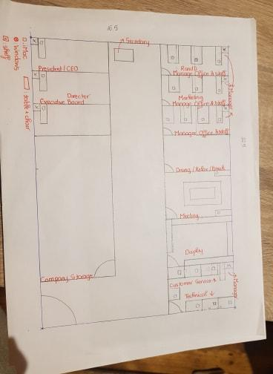

**Target Market**

Describe your target market in terms of age, education level, income, and other demographic variables.

* There is no specific target market in this industry. As long as you are looking for a sneaker, business shoes, you are qualify for our product. We want to bring our product plus great design from designer to our customer with no limit of age, gender and income

**Product Features and Benefits**

Describe the features and benefits of your product or service.

* What we offer customer is a one stop shoes service. What that mean is instead of going from store to store to find a design that they like, they can ask our partnered designer to customize for them and we will responsible for shoes making process. With that, we can stand out from our popular enemy.

**Product Differentiation**

How will you make your product stand out in the crowd?

* As we’ve said, because we offer customer to customize their own shoes via our partnered designer, they can even stay at home, select the shoes type, model and design and make a payment. These process can be done as quick as 5 minutes. Without have to looking from brand to brand, store to store to find a pair of shoes, save your time doing something else.
* In the other hand, we can offer customer a way to cut down the cost of their shoes but still ensure that they can get the product design they want. Each month we will release 100 shoes design. Customer can vote for the model they want to get and as long as a model reach 50 demand, we will make that design. A $20 fee will be credited from the customer’s account to make sure they get the product once it finished producing.

**Pricing**

What pricing strategy will you choose for your product, and what are the reasons for this strategy?

* Due to high designing fee, after we get some room in the market, we need to sell our shoes $150 a pair (originally was $100). If the customer purchasing the same design for a large amount, the cost for each pair will be reducing to as low as $100 a pair. Comparing to the market, the price is quite high but comparing for benefit, the customer can gain much more from us (save time, preferred design)

**Place (Distribution) Issues**

Where will customers find your product or service? That is, what issues of the distribution mix should you consider?

* Our main method will be online, where customer can connects with a designer and designer will send design model to us for shoes making. We also have a display room in our office and manufacture where customer can visit and have a look at the most popular 3D design.
* Right now, we are planning to open a demo store, where customer can meet designer face to face, tell them what they want and get the sketch finished right away. Customer then pay for the design and product, wait and get it shipped directly to their home. It’s hard to open a physical store for this business model but we will try and develop from it

**Advertising**

How will you advertise to your target market? Why have you chosen these forms of advertisement?

* We will advertise heavily on Facebook, Instagram and Youtube as they are most used software for all target customer and people spend at least 50% of their time on those social media, therefore, it’s the most efficient way so far. It will be costly from the beginning but we accept a great loss from the beginning to gain something more valuable. We cannot advertise our product/service just using a billboard or image as it will not fully demonstrate our ideas and customers will have no idea what we are offering. Once we have gain a certain amount of customers and orders, we will slow down our adverts on those platform and expand to new platform such as games ads, app’s ad or even radio communication. Radio Communication is actually a new method. Customers will listen and get themselves surprise to the advertisement.

**Promotions**

What other methods of promotion will you use, and why?

* We do offer new customer a 10% discount for their first shoes. Within the first 2 year, for every 5 pairs they purchase, the 6th one will get an extra of 10%. Every friend referral(with first purchase successfully) will get 5$ off their next order. We are willing to put down about $50 for every customer to populate our market, as this can also be considered as advertising.
* We are thinking about giving rank for each customer. With a certain amount spend on our product, they can achieve a higher rank, which unlock more discounts.

**Startup Costs**

How much money will you need to get your business started?

* Based on the plan, we would need approximately 2 millions for the first year. We are trying to earn as much as we can on the first year so next year the cost can go down by ¼. We all expecting a loss on the first year due to equipment needs to equip versus the amount of sale.
* Cash on hand will be about $1 million and the other $1 million we will try to get from the bank or investor/angel investor

**Financing**

How will you finance your business? For example, will you seek out a bank loan? Borrow from friends? Sell stocks or bonds at the outset, or as your business grows?

* What we will do is to get a loan from the bank as much as we can with a reasonable interest. We also allow investor who can see our potential and ideas to join, with a maximum of 49% shares and some conditions (such as buy back after x years for x times from the original investing).